**10. Solution Architecture**

**10.1 Overview**

The *College Food Choices Visualization System* follows a **modular and scalable architecture**, designed to ingest raw data, process it into insightful dashboards using Tableau, and present it through a Flask-based web application for user access.

This architecture supports **ease of data preparation, visual storytelling, and seamless user interaction** — with minimal backend complexity and high usability.

**10.2 Architecture Layers**

| **Layer** | **Description** |
| --- | --- |
| **Data Layer** | Stores structured CSV files containing dietary, lifestyle, and health metrics |
| **Preparation Layer** | Cleans and transforms data using Tableau Prep or Excel |
| **Visualization Layer** | Creates interactive dashboards and storyboards in Tableau Desktop |
| **Hosting Layer** | Publishes dashboards on Tableau Public or Tableau Server |
| **Web Interface Layer** | Uses Python Flask to embed the dashboard inside a clean web UI |
| **User Access Layer** | Students, researchers, and faculty access the dashboards via browsers |

**10.3 Architecture Diagram**

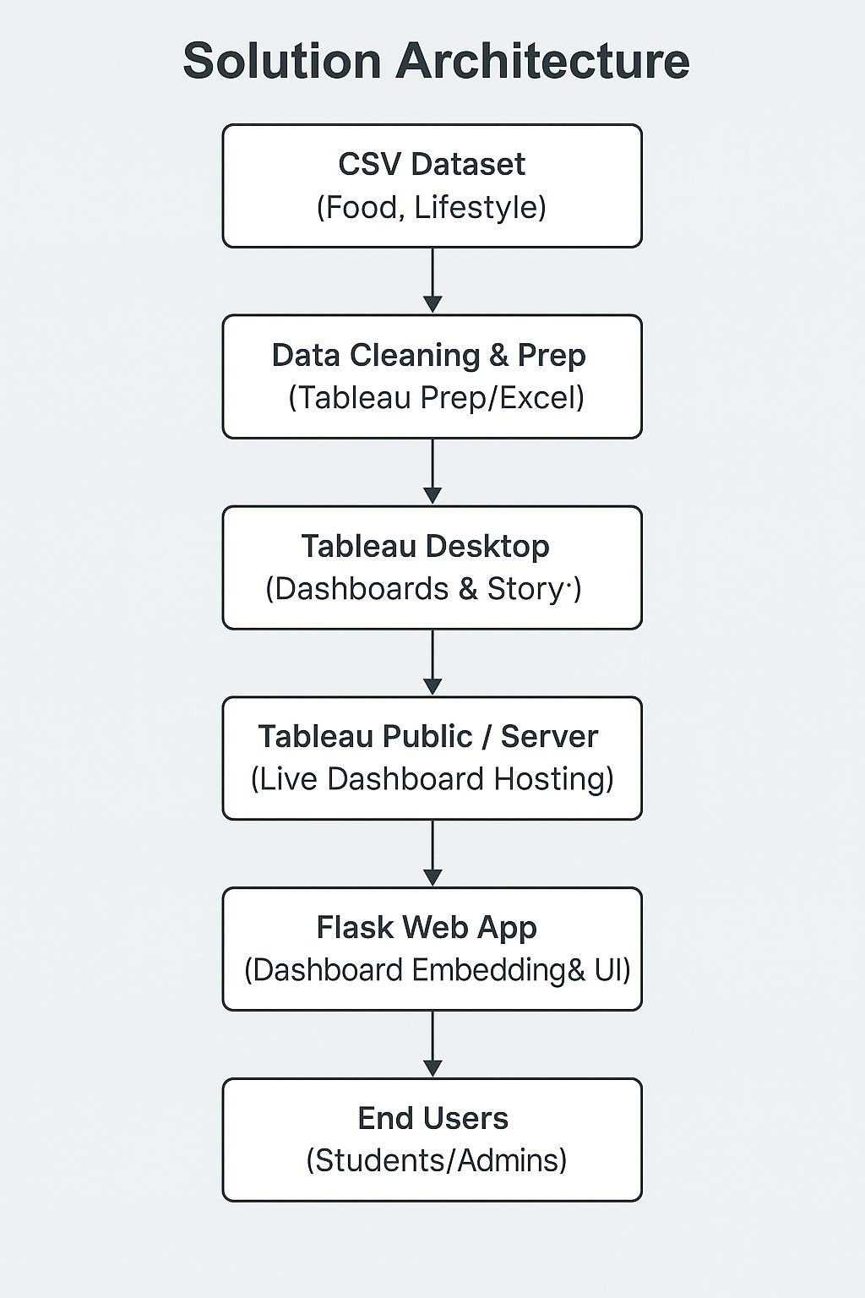You can visualize the architecture as follows:

You can create a **visual diagram** from this using draw.io, Canva, or Lucidchart for your final report/PPT.

**10.4 Key Characteristics**

| **Characteristic** | **Details** |
| --- | --- |
| **Modularity** | Each layer functions independently, allowing easy updates and scaling |
| **Lightweight Backend** | Flask used solely for front-end embedding; no heavy backend logic involved |
| **Platform Independent** | Dashboards are web-based and work on all major browsers and devices |
| **Security Compliant** | No PII involved; dashboards are shared securely via Tableau Public/Server |
| **Extensibility** | Future datasets can be integrated with minimal changes to the architecture |

**10.5 Advantages of the Architecture**

* ✅ **Quick Development Cycle** – Rapid prototyping using Tableau
* ✅ **Seamless Deployment** – Minimal setup using Flask and Tableau Public
* ✅ **User-Centric Interface** – Designed for students, staff, and health professionals
* ✅ **Maintainable & Scalable** – Easily update data, visuals, or embed logic